LabVIEW Adapter Configuration Dialog for SaveVersion Feature

Revised: 8/8/2024 10:00 AM
TestStand Version: 2024 Q3
Author: Vishal S
Feature Spec:
Dependencies: Perforce

Description
LabVIEW adapter dialog behavior has been changed. If “Version Independent Runtime Engine” (BCRTE) is enabled, we don’t disable the RTE Version combo box anymore. We let users to change the RTE Version when BCRTE. We only disable it when “Build Source Files and Execute Files” option is enabled.

Preparation
- Install TestStand 2024 Q3 or later
- Install LabVIEW 2024 Q3 or later
- Sync files from \\TestStand\WebPages\TestCases\Adapters\LabVIEW\SourceOnlySupport\SaveVersion Media\

Note:
- The test media is saved in LabVIEW 2021, if you are modifying the files, it should be saved in the least supported LabVIEW version
- The following abbreviations are used throughout the document
  - BCRTE – Version Independent Runtime Engine
  - BnE – Build Source Files and Execute

Validation
BnE and BCRTE is unchecked at launch:
- Launch TestStand
- Open LabVIEW adapter settings and change settings to match the below screenshot and restart if required (RTE version should not be AutoDetect)
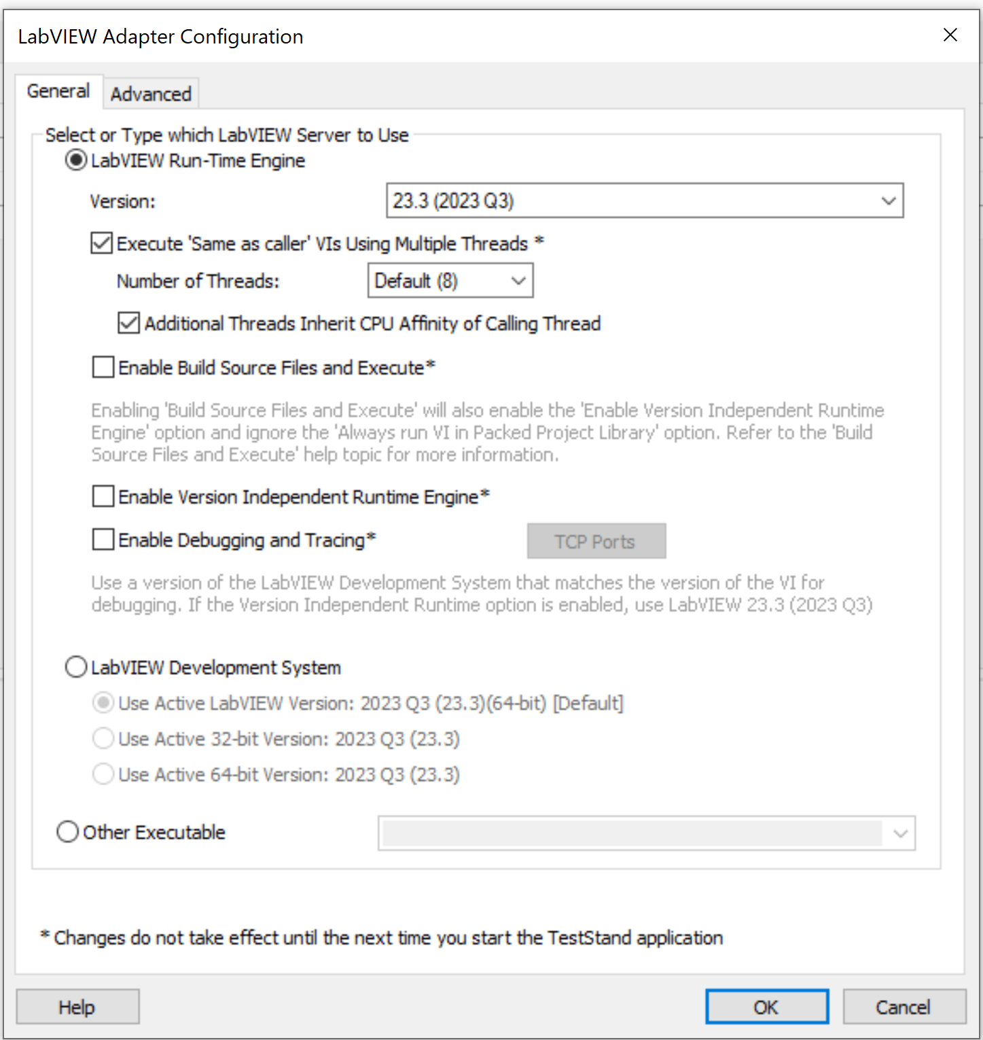
- Check “Version Independent Runtime Engine” option
- Verify that the LV RTE version combo box is still enabled and set to AutoDetect
- Verify RTE version can be changed to a specific version (lets say 23.3) and click OK
- Open the dialog box again and ensure that the values are retained
- Change the version to a different version (AutoDetect), then select LabVIEW dev and click OK
- Open the dialog box again and ensure that the values are retained
- Select LabVIEW Run-Time Engine server and click OK
BnE is unchecked and BCRTE is checked at launch:
- Launch TestStand
- Ensure “Build Source Files and Execute” is unchecked and “Version Independent Runtime Engine” is checked at launch, restart if required
- Uncheck “Version Independent Runtime Engine”
- Verify RTE version combo box is still enabled and earlier set version is retained
- Set RTE version to 23.3
- Check “Build Source Files and Execute” option
- Verify “Version Independent Runtime Engine” gets checked, LV RTE version is set to “AutoDetect” and gets disabled
- 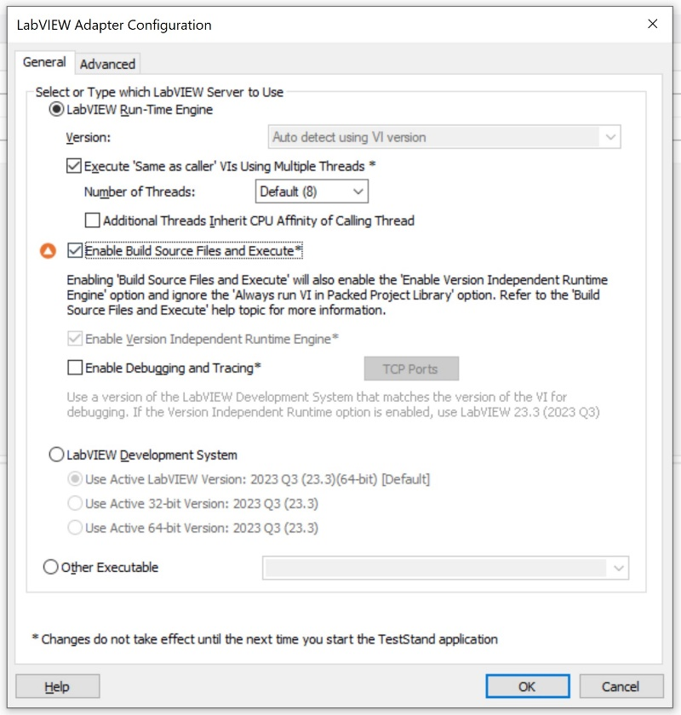
- Uncheck “Build Source Files and Execute” option
- Verify “Version Independent Runtime Engine” is still checked and version combo box gets enabled and you can change the version
- Open the sequence file ‘ChangeLVAdapterSettings’
- Run the step “Set LabVIEW server to use RTE and use 23.3 version”
- Verify you do not see any error
- Run the step “Set LabVIEW server to use RTE and use AutoDetect”
- Verify you do not see any error

BnE is checked but enabled at launch:
- Launch TestStand
- Ensure “Build Source Files and Execute” is checked at launch, restart TestStand if required
- Uncheck “Build Source Files and Execute” option
- Verify you see the below error and Version combo box is still disabled and set to “AutoDetect” (This is because we don’t let users to change RTE version if “Build Source Files and Execute” was checked and enabled at launch)
- 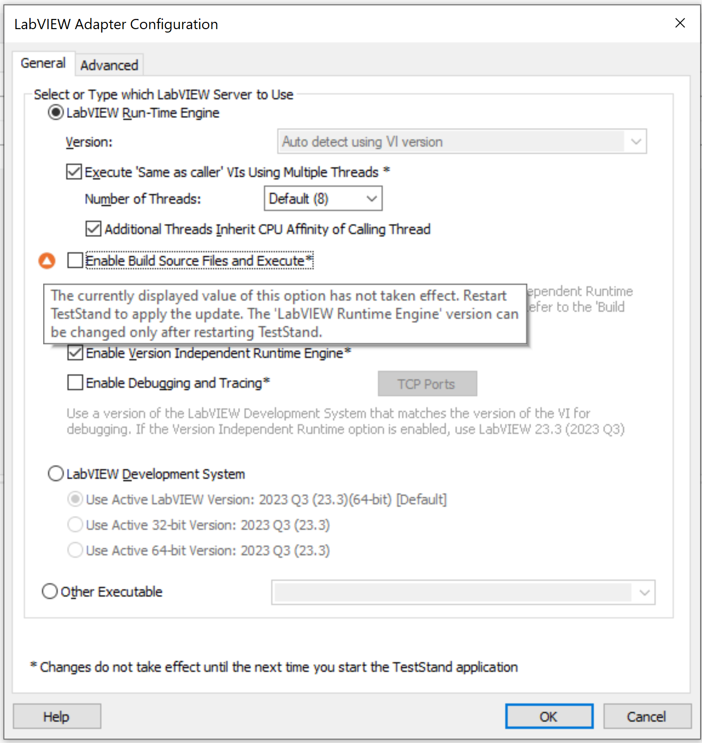

BnE is checked and disabled at launch:
- Launch TestStand
- Check “Build Source Files and Execute” option and ensure “Version Independent Runtime Engine” is checked and disabled and Version combo box is still disabled and set to “AutoDetect”
- Close TestStand
- Change Active LabVIEW version to LabVIEW 2022 or older
- Launch TestStand and open LabVIEW adapter dialog
- Verify the dialog looks like this where “Build Source Files and Execute” is disabled and the label matches
- 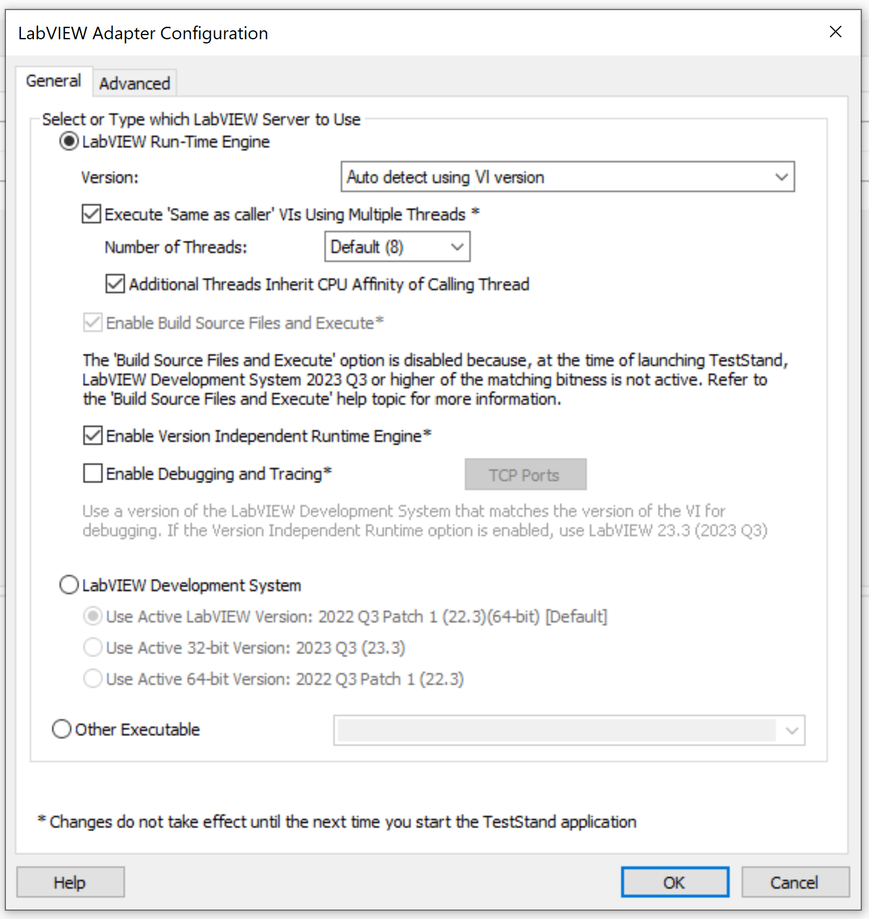
- Change RTE Version to a specific version (23.3)
- Click OK and close TestStand and the older version LabVIEW
- Launch LabVIEW 2023 Q3 or higher
- Launch TestStand and open LabVIEW adapter dialog
- Ensure RTE version is disabled and set to “AutoDetect”
- 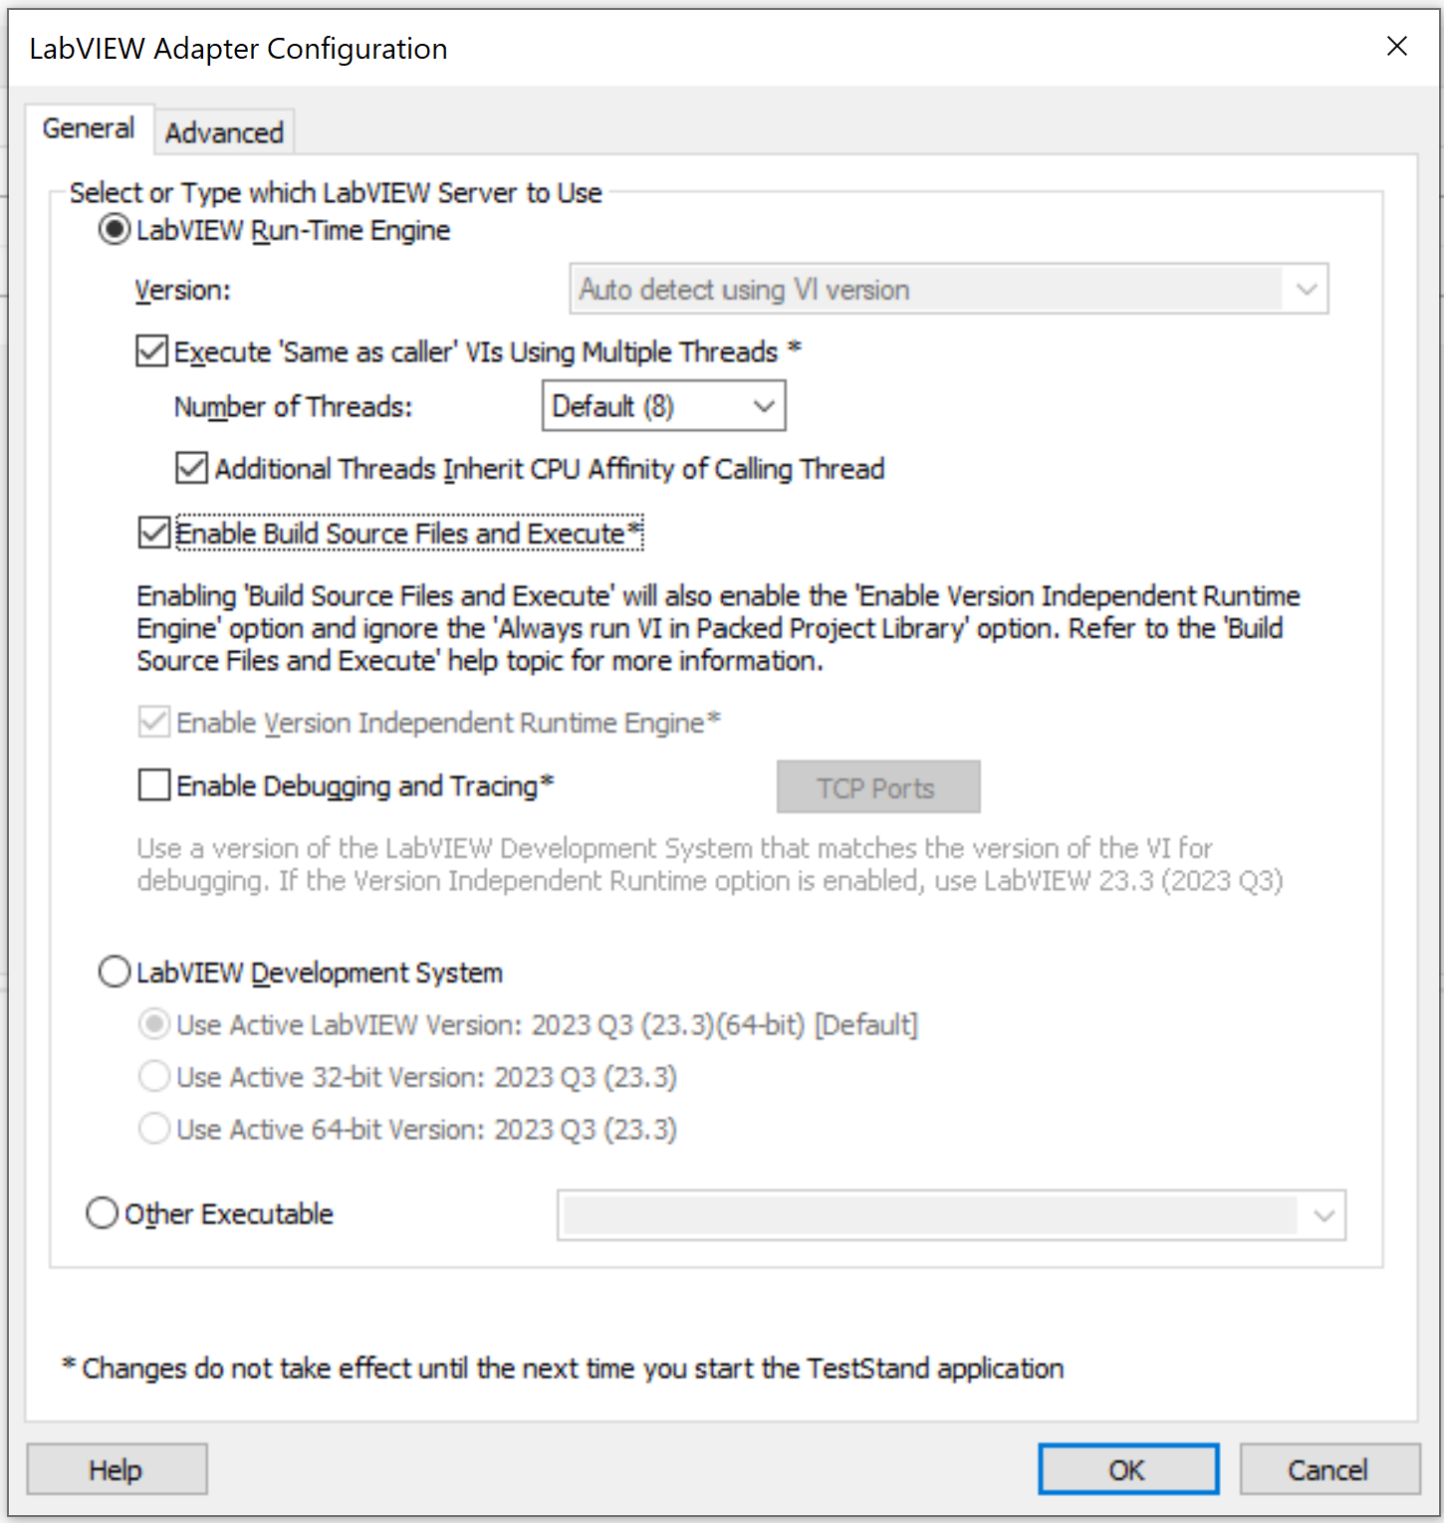
- Open ‘SaveVersion Media\ChangeLVAdapterSettings.seq’
- Run the step ‘Disable "Version Independent Runtime Engine"’
- Verify you see the below error and click OK
- 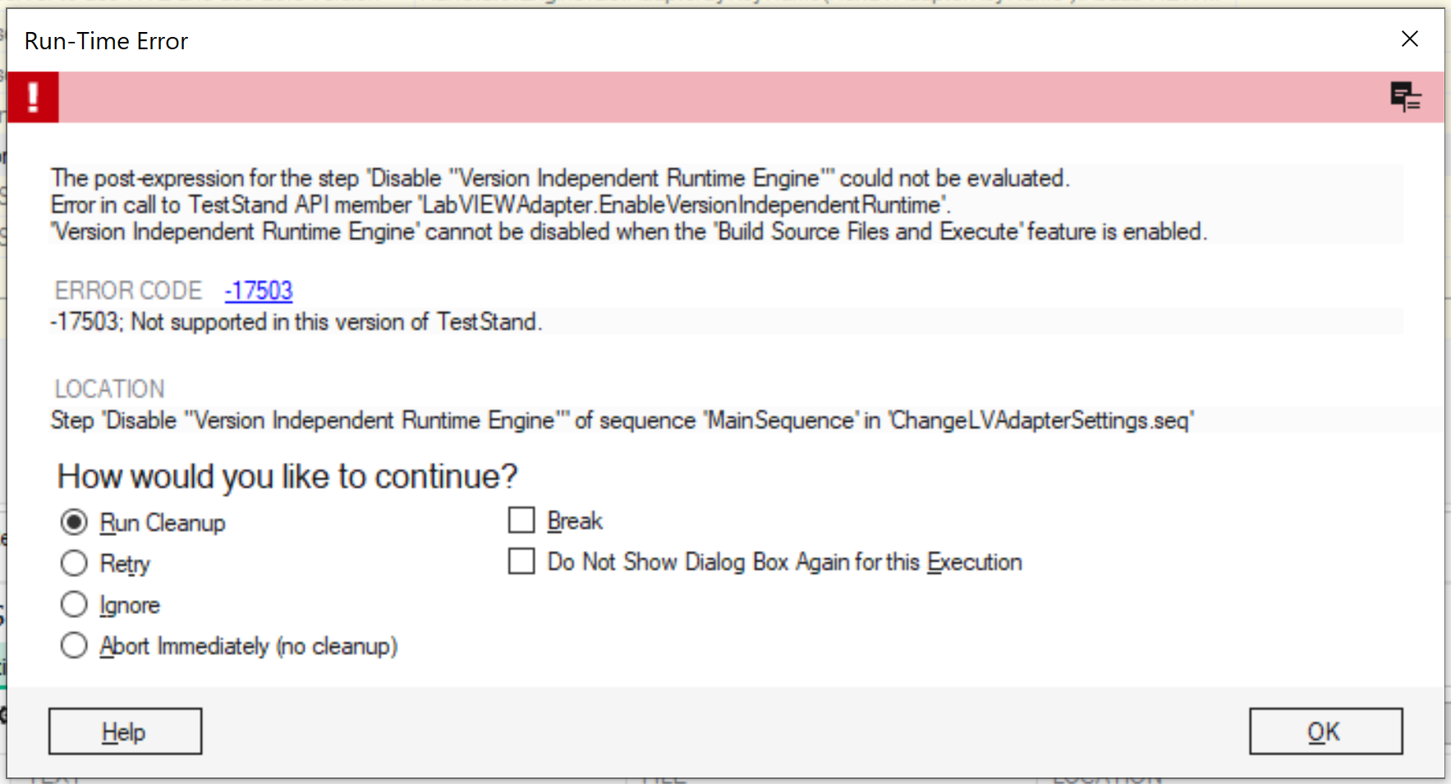
- Run the step “Set LabVIEW server to use RTE and use 23.3 version” (you can change the step to use specific version that is installed with TestStand)
- Verify you see the below error and click OK
- 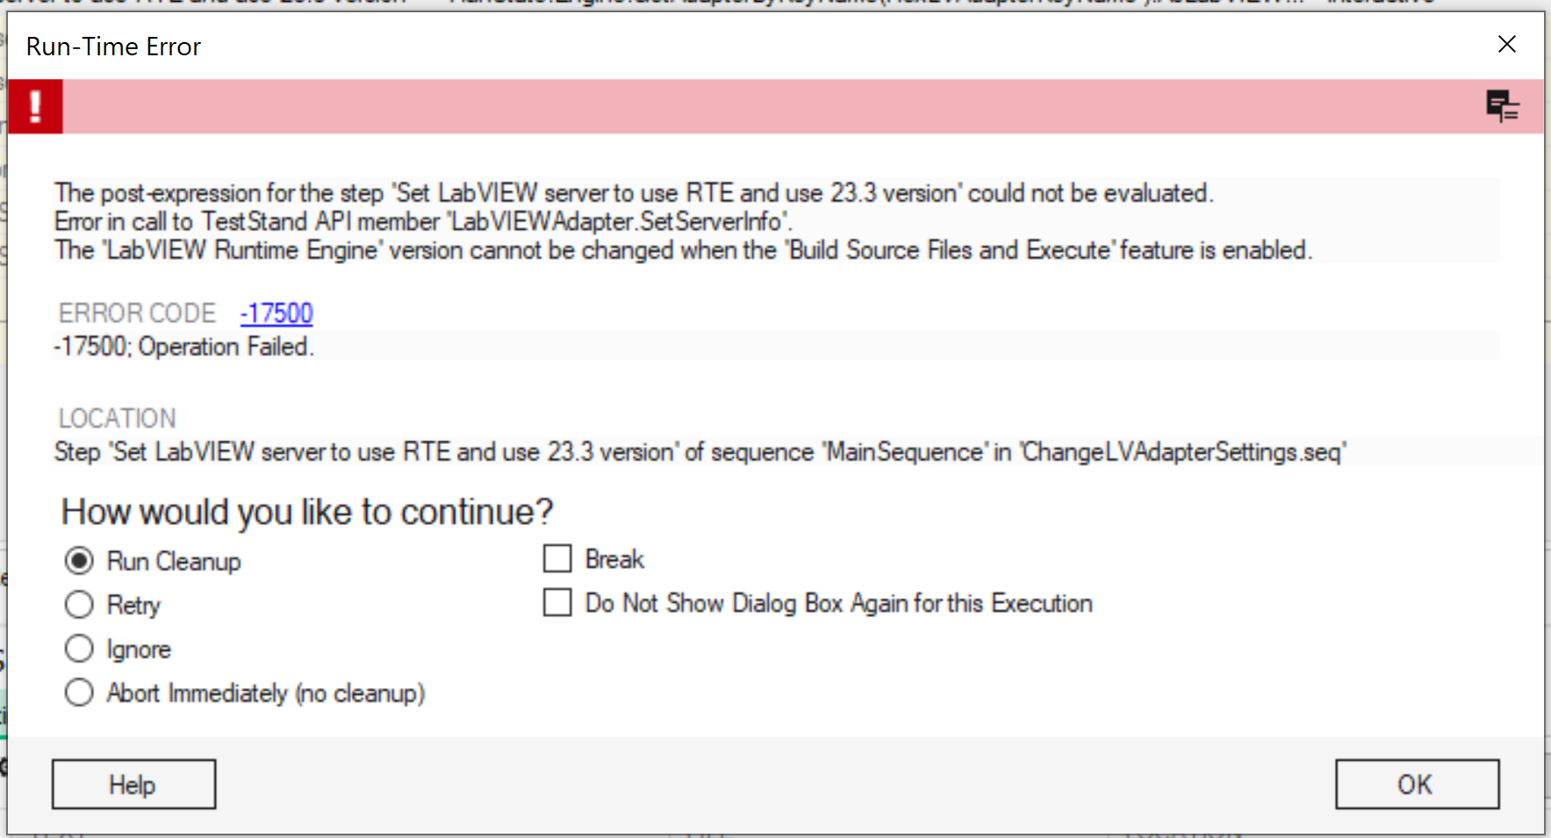
- Run the step “Set LabVIEW server to use RTE and use AutoDetect”
- Verify you do not see any error

Change LabVIEW adapter settings using API:
- Launch TestStand
- In the above scenarios, replace setting the options from UI with setting the options using APIs (You can use ‘SaveVersion Media\ChangeLVAdapterSettings.seq’, which has different steps to set different options using API.)
- Ensure the API set values reflect in UI

Changes between RTE and Dev:
- Launch TestStand
- Change RTE version and state of “Version Independent Runtime Engine” option
- Select LabVIEW dev as the server
- Click OK to close the dialog box
- Launch the adapter configuration dialog box again and ensure the settings are retained.

